**Objective:**

In this final assignment, you will be able to:

1. Create a blank Jupyter Notebook in the Watson Studio environment.
2. Create Markdown cells.

**Instructions**

This course introduced you to multiple data science tools, and in this final project, you will use the Jupyter Notebook, one of the easiest tools to share publicly.

**Exercise 1: Create a blank Jupyter notebook in the Watson Studio environment**

* Log in to your IBM cloud account and launch the Watson studio.
* Create a new project and add a new asset as **Jupyter Notebook editor**.
* Create a blank notebook.

**Exercise 2: Create Markdown cells**

* **Cell 1 (rendered as Markdown)**: The title should be “My Jupyter Notebook on IBM Watson Studio”, in H1 header style. The title is not center aligned.
* **Cell 2 (rendered as Markdown)**: Include your name, in bold. In the next line, write your current or desired occupation in regular font.
* **Cell 3 (rendered as Markdown)**: In italics, write one or two sentences about why you are interested in data science. For example, you can start your first sentence with “I am interested in data science because…”.
* **Cell 4 (rendered as Markdown)**: In H3 header style, describe your code in Cell 5 using a few short sentences.
* **Cell 5 (code cell)**: Enter your code, as described in Cell 4. It must be executed and must display an output. Try to keep the code simple (it can even be “1 + 1”).
* **Cell 6 (rendered as Markdown)**: Using Markdown or HTML, this cell must include at least three of the following: bulleted list, numbered list, tables, hyperlinks, images.

**Steps to complete the assignment in Watson Studio**

**Leveraging Jupyter Notebook on the IBM Watson Studio, you will create your own Jupyter Notebook (in English) and share it via a public link.**

**How to generate a publicly viewable share link for your Jupyter Notebook:**

**Step 1.** With a Jupyter Notebook open on Watson Studio, first ensure that you save the notebook. Click **File**, and select **Save Version**,as shown below.

How to generate a publicly viewable share link for your Jupyter Notebook:

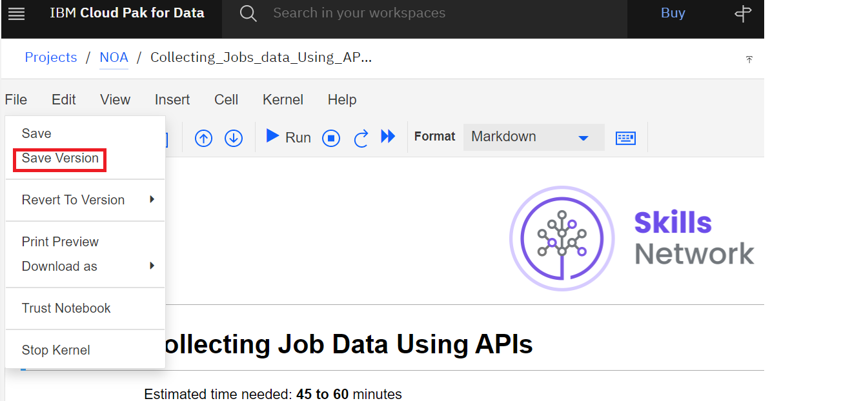

**Step 2.** Click the **Share** button, as follows:

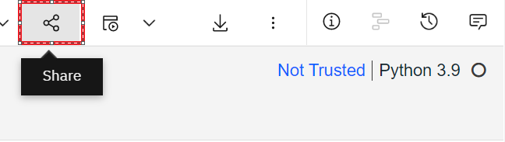

**Step 3.** Select the following settings to retrieve a public link to your Jupyter Notebook:

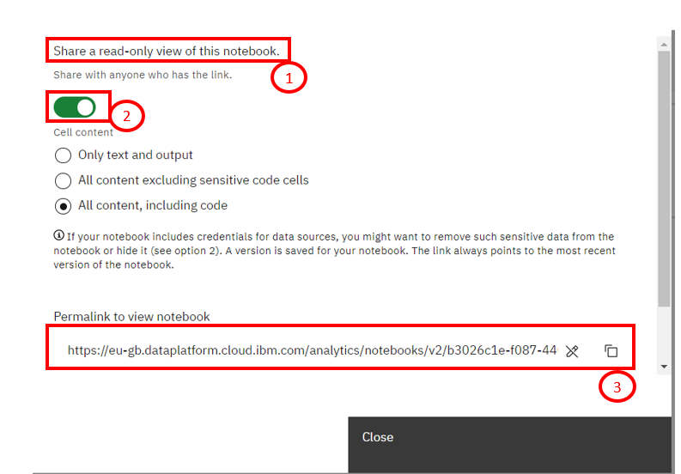

* Watson Studio is a helpful tool for:
  + Analyzing and viewing data
  + Cleaning and shaping data
  + Embedding data into streams
  + Creating, training, and deploying
* Learning Watson Studio promotes career growth.
* Learning Watson Studio is easy and requires no special skills.
* Watson Studio offers many available resources.
* You must create an IBM Cloud account to use Watson Studio.
* You can open Watson Studio by clicking Catalog on the IBM Cloud dashboard and then AI/Machine Learning.
* You can create an empty project or a project from a sample or file by selecting the Work with data option.
* You can add a storage service by clicking Add and then selecting the storage service of your choice.
* You can add or create a new notebook by clicking **New asset** on the project home page under the **Assets** tab.
* You can share your notebook without sharing the sensitive cells.
* Jobs are created and scheduled from the **Create a job** icon in the notebook action bar.
* Jobs can be viewed, edited, or deleted on the project home page under the **Jobs** tab.
* Jupyter Notebook runtime environments and templates can be found on the Environments tab in the Home Page.
* You can create and change new Jupyter Notebook templates.
* Watson Studio accounts can be integrated into GitHub.
* You can push notebooks from Watson Studio to GitHub.